Project Design Phase

Problem – Solution Fit Report
Project: Script-Controlled ACL – Restrict Record Access Based on Field Value
Date | 1 October 2026
SWTID-2026-7653 | SWTID-2026-7653
Project Name | Script-Controlled ACL – Restrict Record Access Based on Field Value
Maximum Marks | 2 Marks

1. Purpose and project context
This report translates the project’s ServiceNow implementation into a Problem–Solution Fit view. The project addresses a concrete access-control problem: users should see and act on institution records only when their role and the record’s Branch value justify the requested operation.

2. Problem–Solution Fit canvas
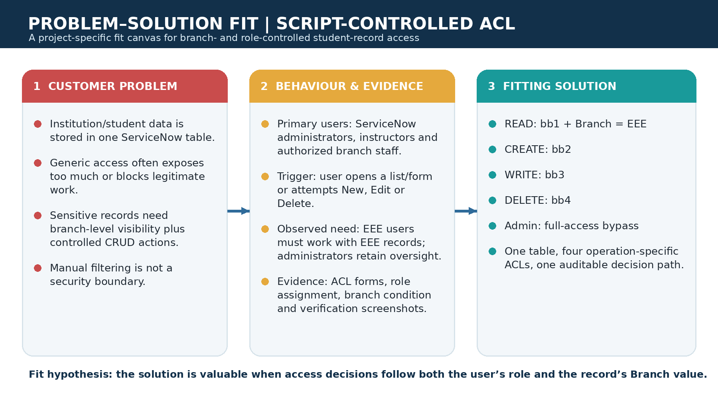
Figure 1. Custom Problem–Solution Fit canvas for the Script-Controlled ACL project.

3. Target users and problem evidence
Dimension | Project-specific finding
Target users | ServiceNow administrators, security administrators, instructors and authorized branch staff who work with institution/student records.
Record context | Custom table `u_institution_details` with Student Roll Number, Student Name, Faculty Name, Branch, Email, Phone Number and Description.
Core problem | A generic table-level permission model cannot express “EEE users may see only EEE records” while also separating read, create, write and delete capabilities.
Risk if unresolved | Unauthorized visibility or modification of student data; over-privileged users; inconsistent controls between list, form and portal experiences.
Existing trigger | A user opens the Student Records list/form or attempts a CRUD action; ServiceNow must decide whether that action is permitted.

4. Proposed fit and value proposition
- Use the ServiceNow ACL layer as the single enforcement point for record-level access.
- Combine role checks with a data condition: the READ ACL uses the custom `bb1` role and Branch = EEE.
- Use a permission ladder: `bb1` for read, `bb2` for create, `bb3` for write, and `bb4` for delete.
- Keep an explicit administrator bypass so authorized administrators retain full operational access.
- Ensure the same policy applies regardless of whether a user reaches the data through a list, form or Service Portal interface.

5. Validation signals
Validation check | Expected outcome | Fit implication
EEE user with bb1 | Can view EEE branch records only | The solution matches the branch-level visibility need.
User without required role | Cannot view protected records | Default-deny behavior limits accidental exposure.
Administrator | Can view records across branches | Operational support remains possible without weakening normal controls.
Role progression | bb1 → bb2 → bb3 → bb4 adds read → create → write → delete | Capabilities are explicit, explainable and auditable.

Evidence of branch-filtered records
The source project includes a ServiceNow list view showing institution records with different Branch values. This is the concrete data context on which the ACL decision is applied.

Project evidence screenshot: Evidence of branch-filtered records

6. Fit conclusion
The project demonstrates a strong problem–solution fit for controlled student/institution data access in ServiceNow. The pain is frequent and security-sensitive, the affected users are identifiable, and the proposed ACL pattern directly changes the authorization decision at the platform layer rather than relying on a visual filter. The fit should be further validated by testing each role combination against EEE, ECE and CSE records in a controlled instance.

References
Primary source: project document “Script-Controlled ACL – Restrict Record Access Based on Field Value,” supplied by the project owner. Template structure adapted from the Phase 3 Problem–Solution Fit Template.

